Testing @ 08/08/16
- Click Invest Now > Message prompted to inform the investor the investment detail was added to My Load Portfolio.

Testing @ 22/08/16 & 26/08/16
- During Installation - Why record Audio?
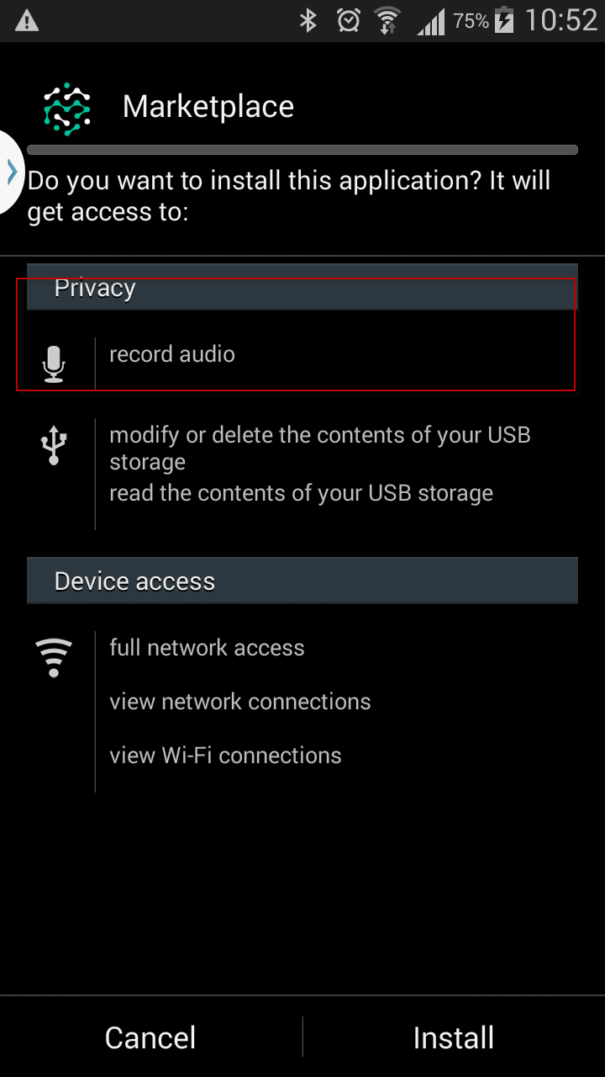

- The dollar value should include Currency i.e. IDR which already in the API.
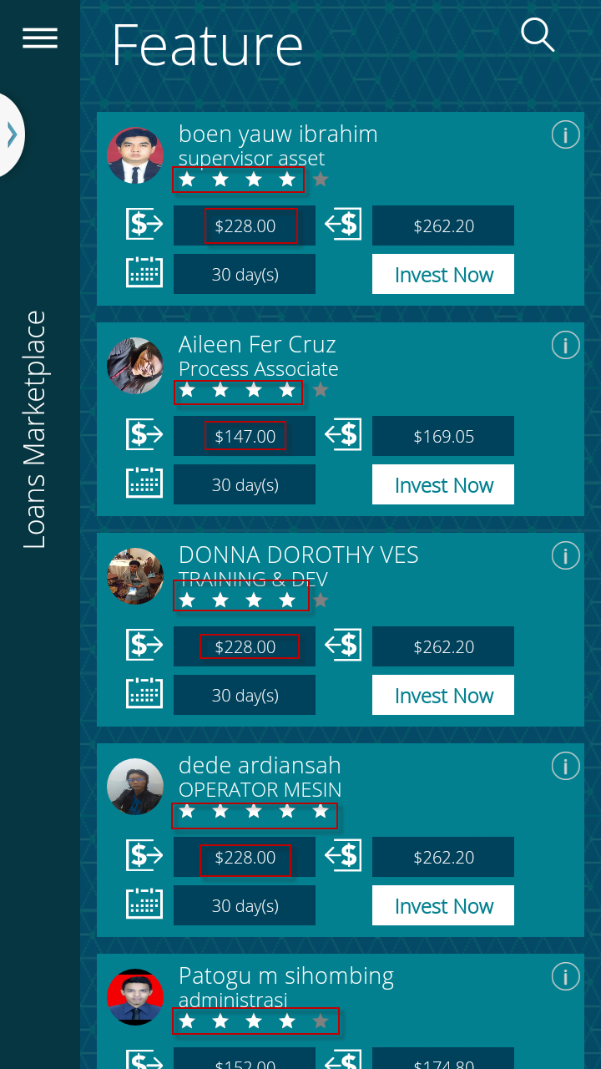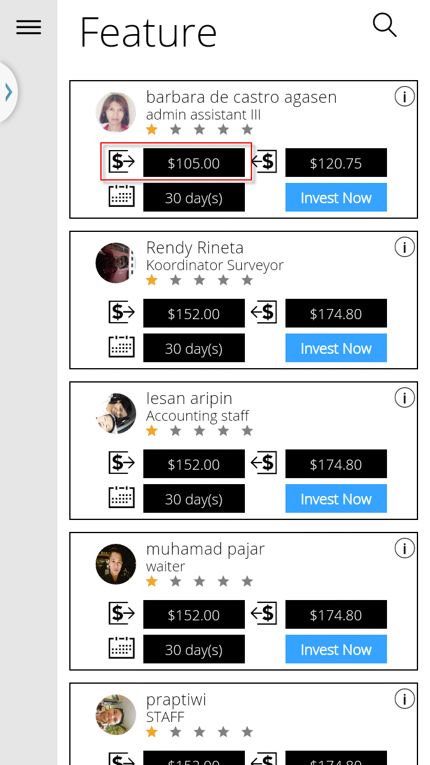

- Login My Profile Change Password Labelling
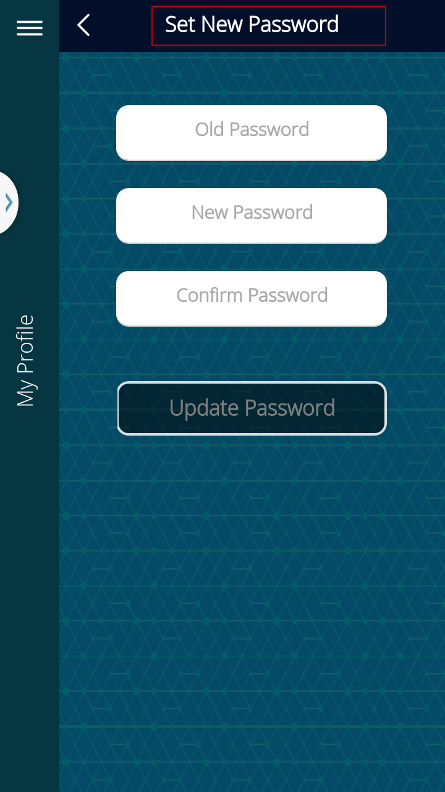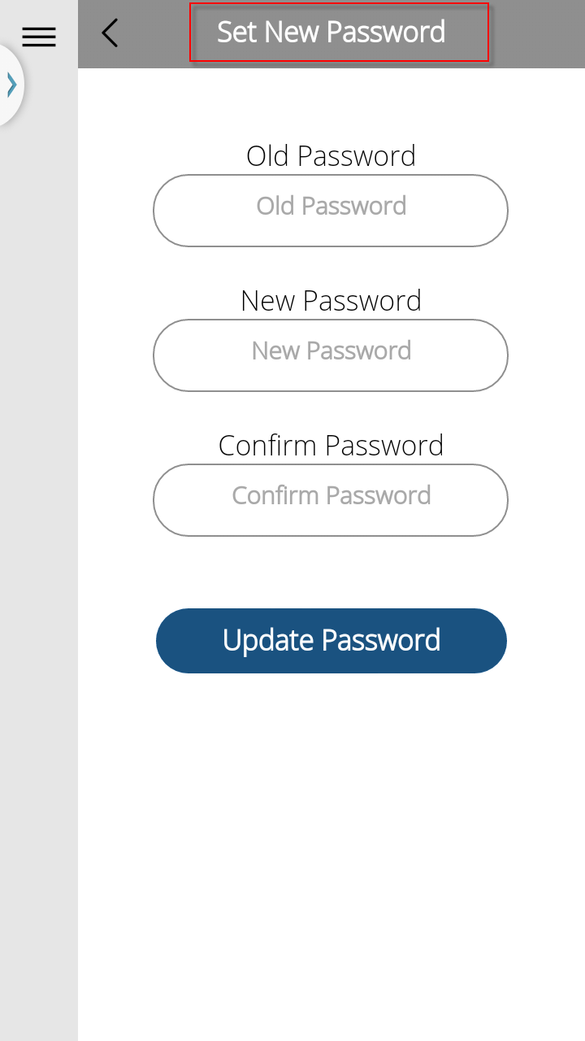

Testing 26/08/16
- White background – What is the font type & its size

- Sign-Up > Remove country default by putting ‘Please Select’, and consistency with Update Address page.

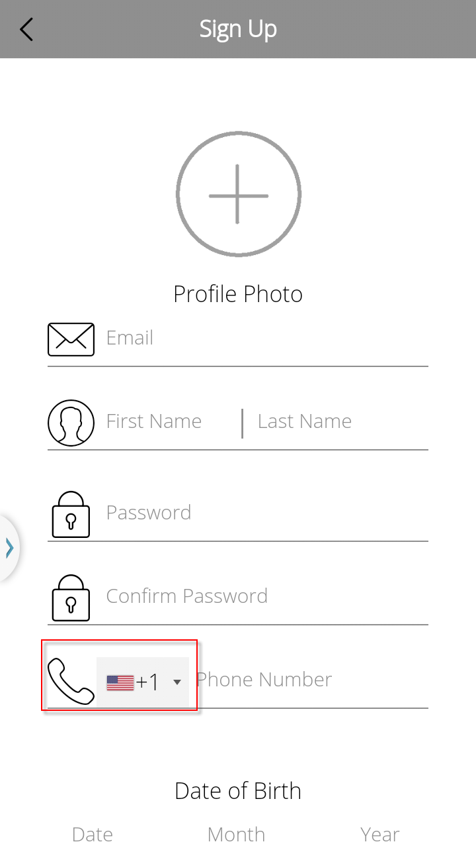

- Scrolling issue – outside the red square box unable to scroll
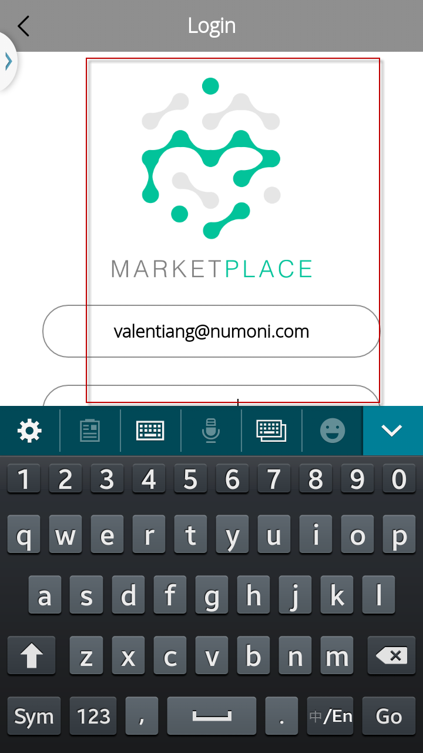

- Page’s height inconsistency
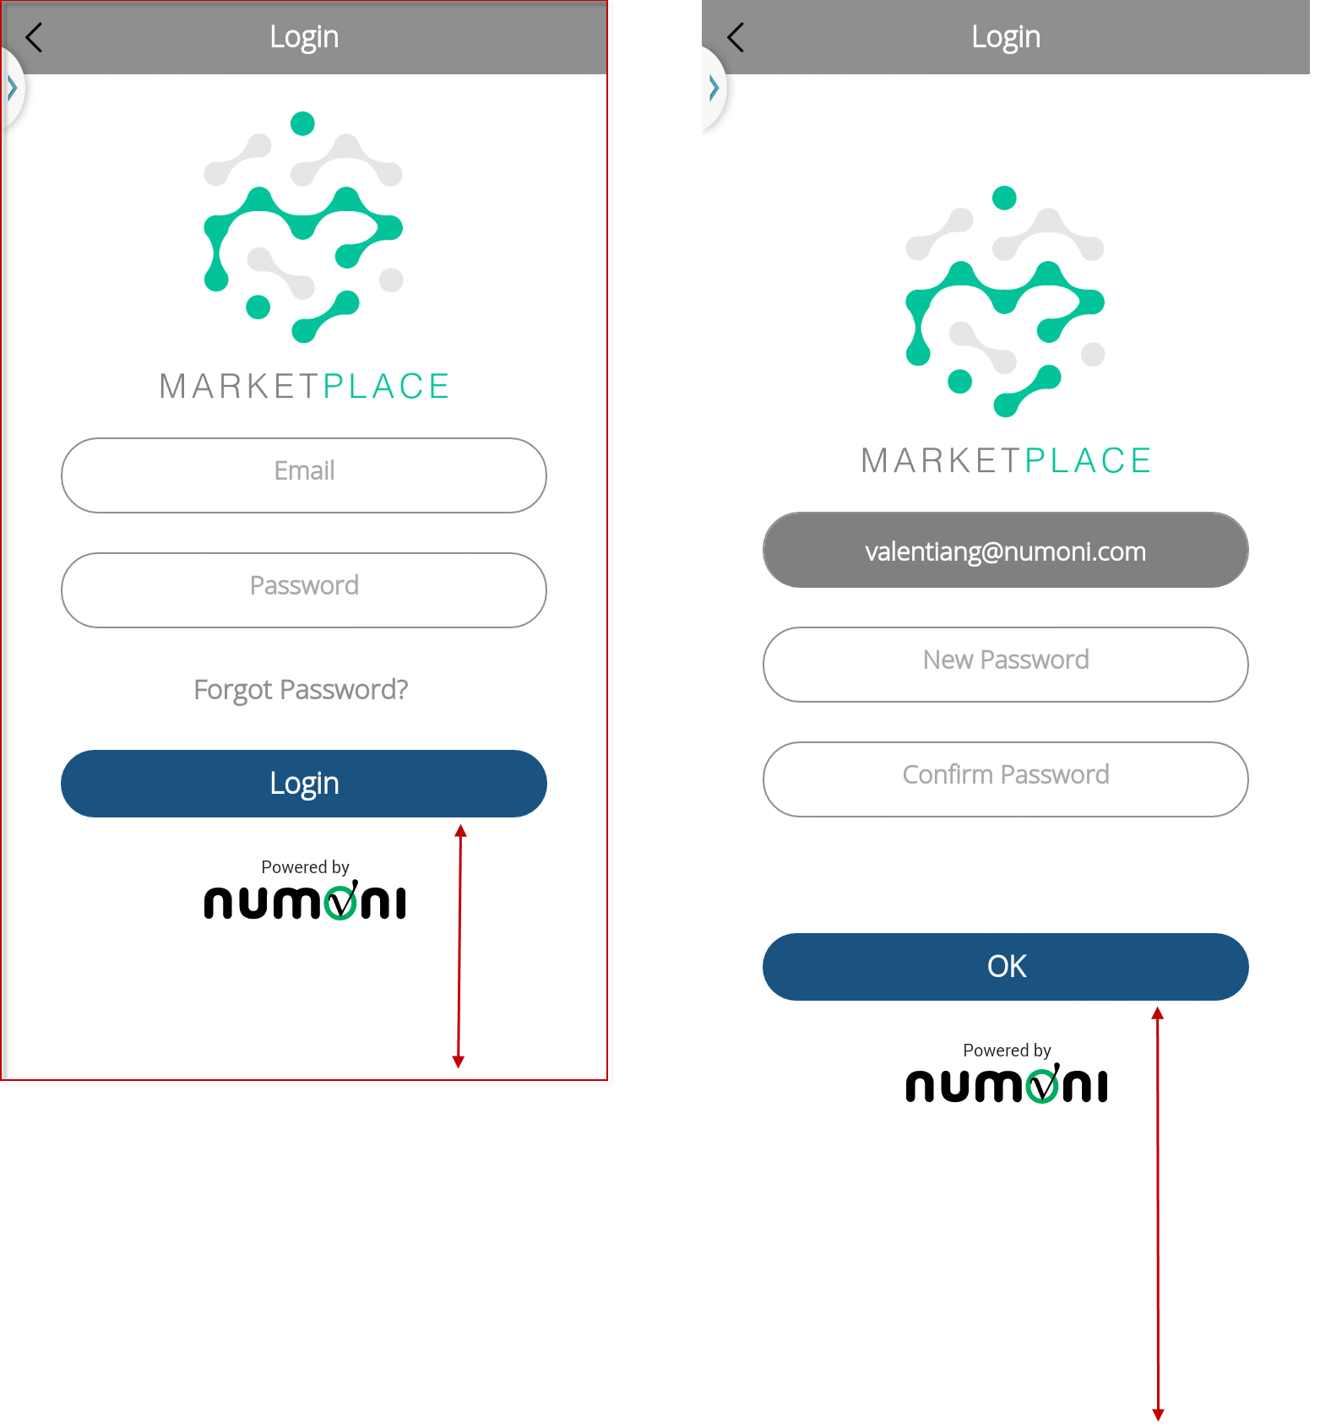
- Login > My Profile > Update Address > fill in address detail > Tap [Update Address] but no details displayed when re-enter Update Address page.
How user know what details he submitted/updated earlier?

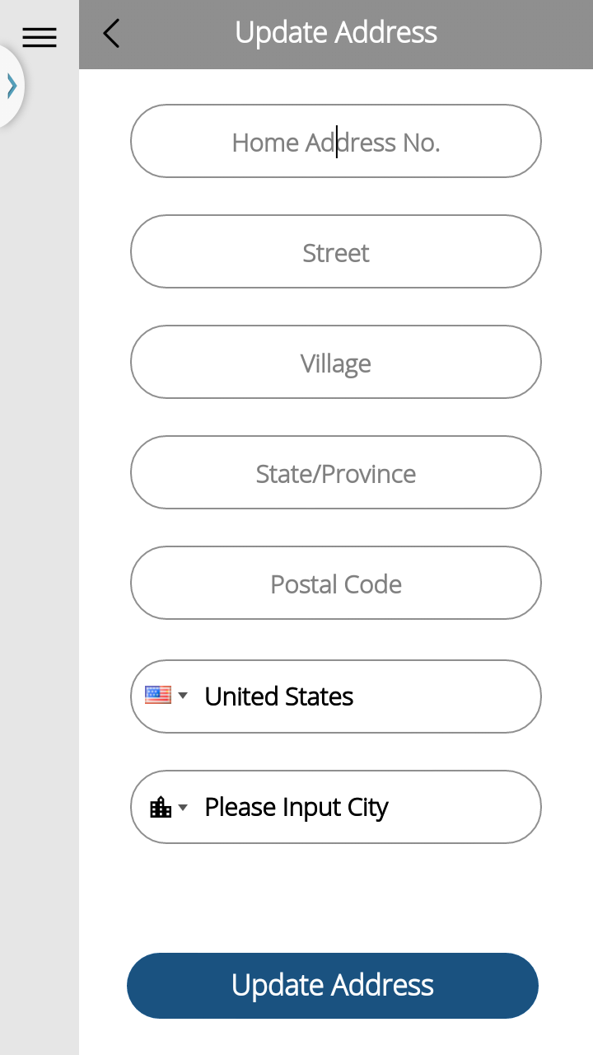 > 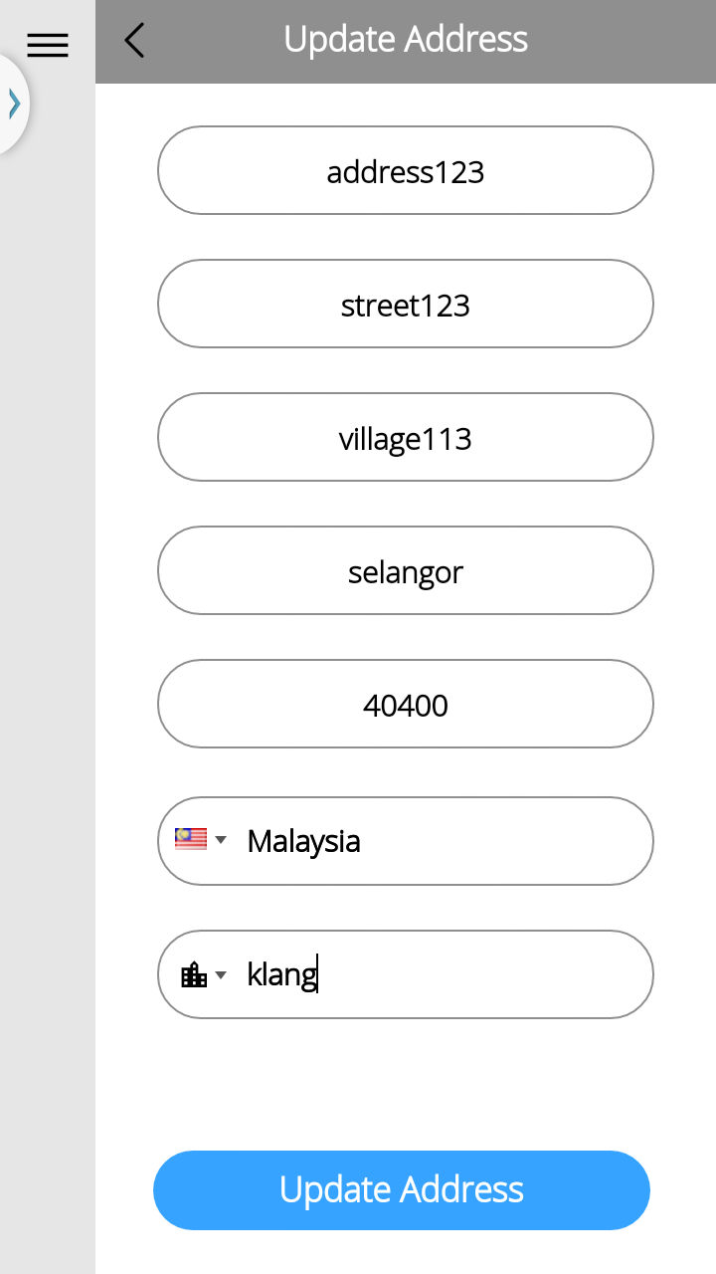>

- Label of Please Input City is not consistency while updating address.
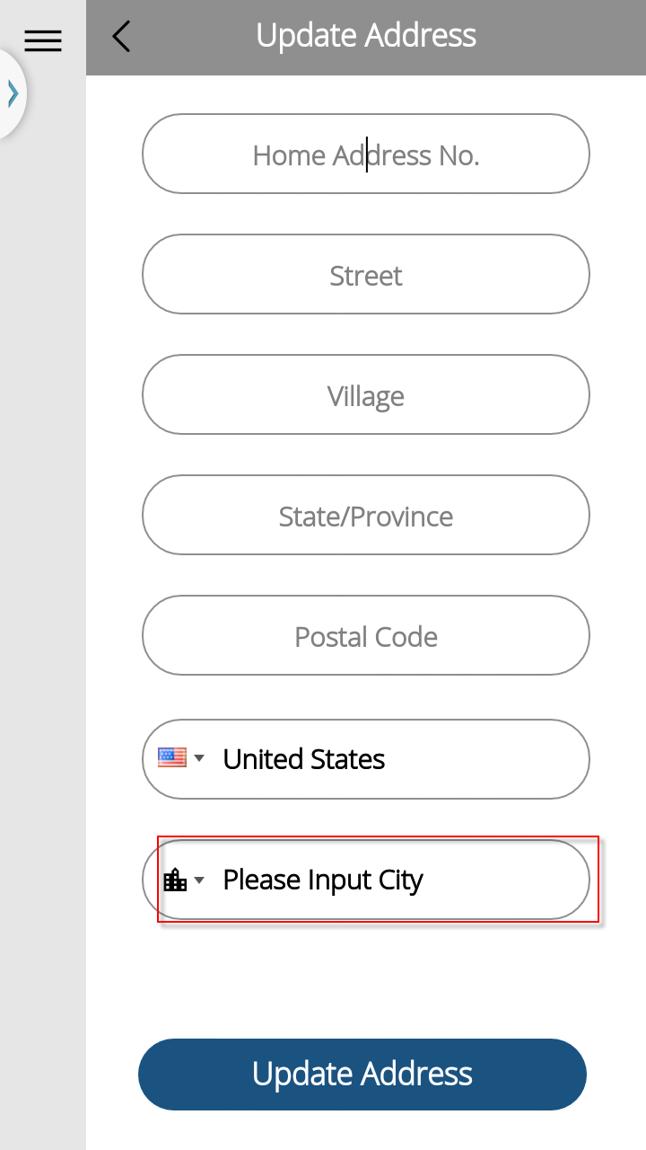> 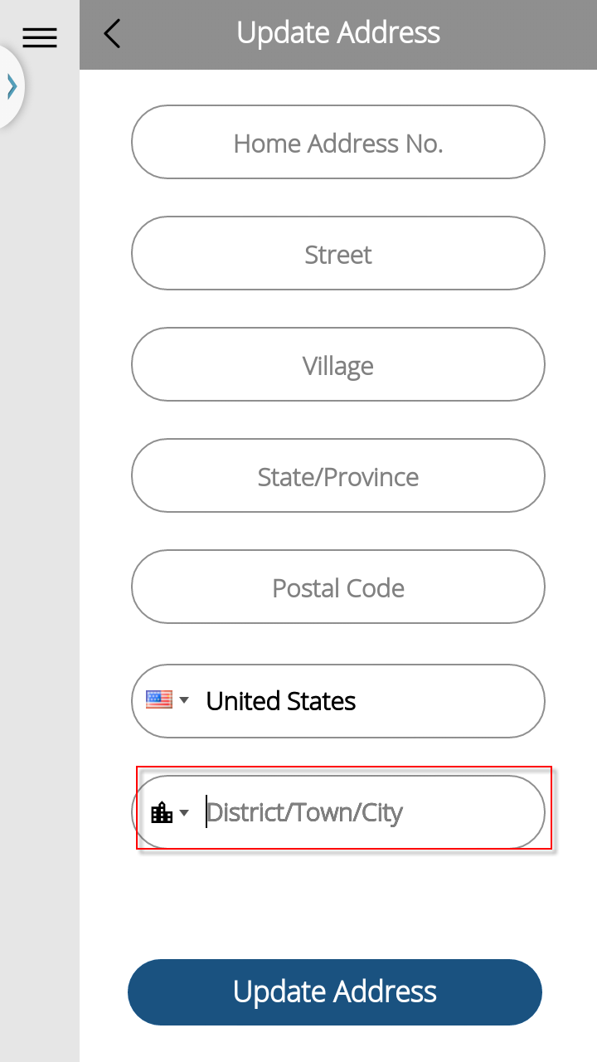

- Remove country default by putting ‘Please Select’, and consistency with Sign-Up page

Enhancement
- Sign up - Phone number – Country code field allows Investor to type i.e. ‘In’ then list all the country start with ‘In’ instead of scroll up and down for such a long list.
